GUIDE Tree Diagrams

Tree for original data.

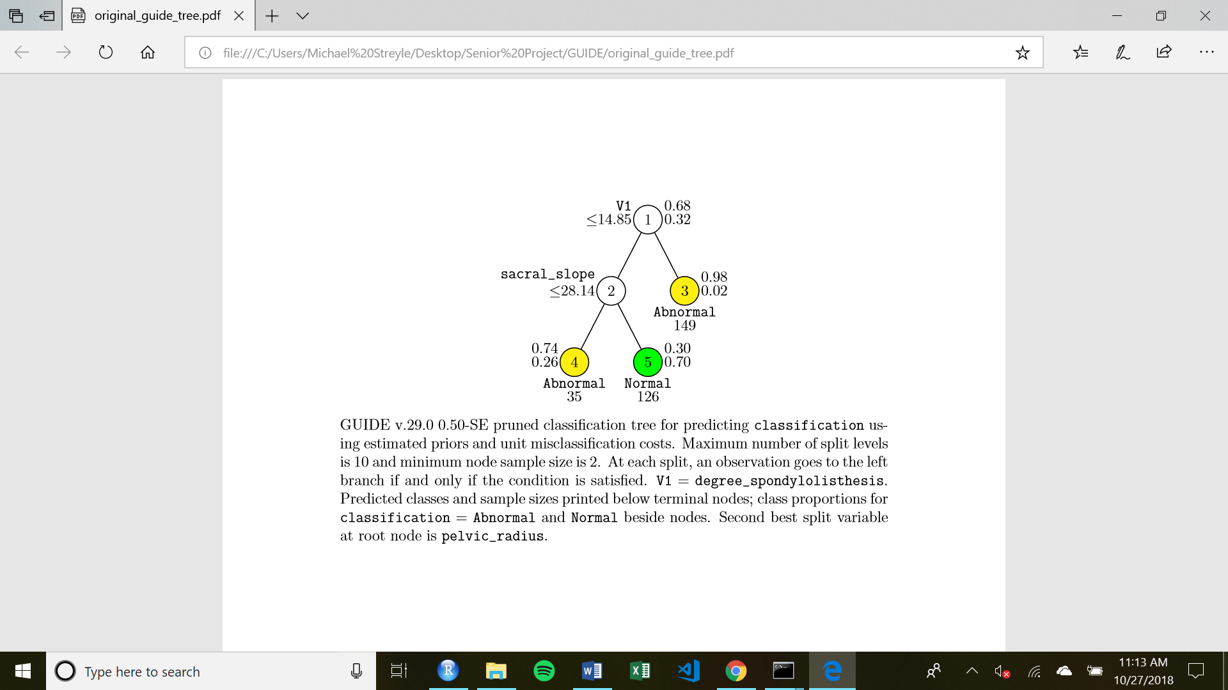

Tree for data with 10 Random Variables

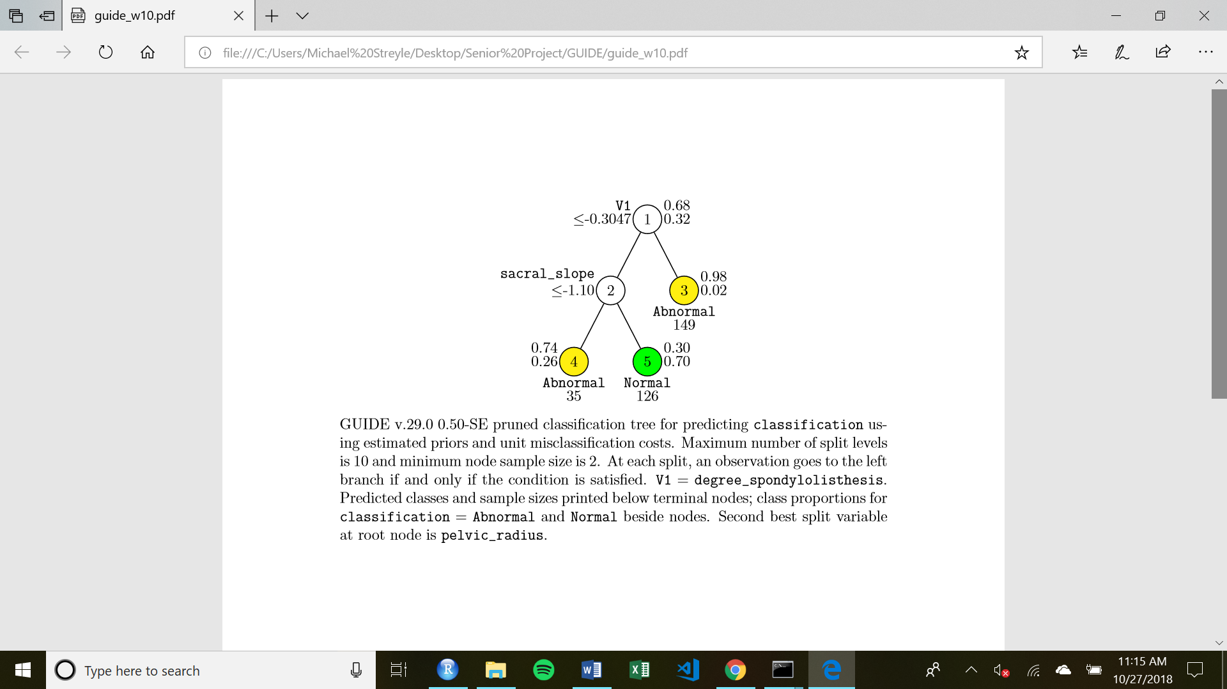

Tree with 100 Random Variables

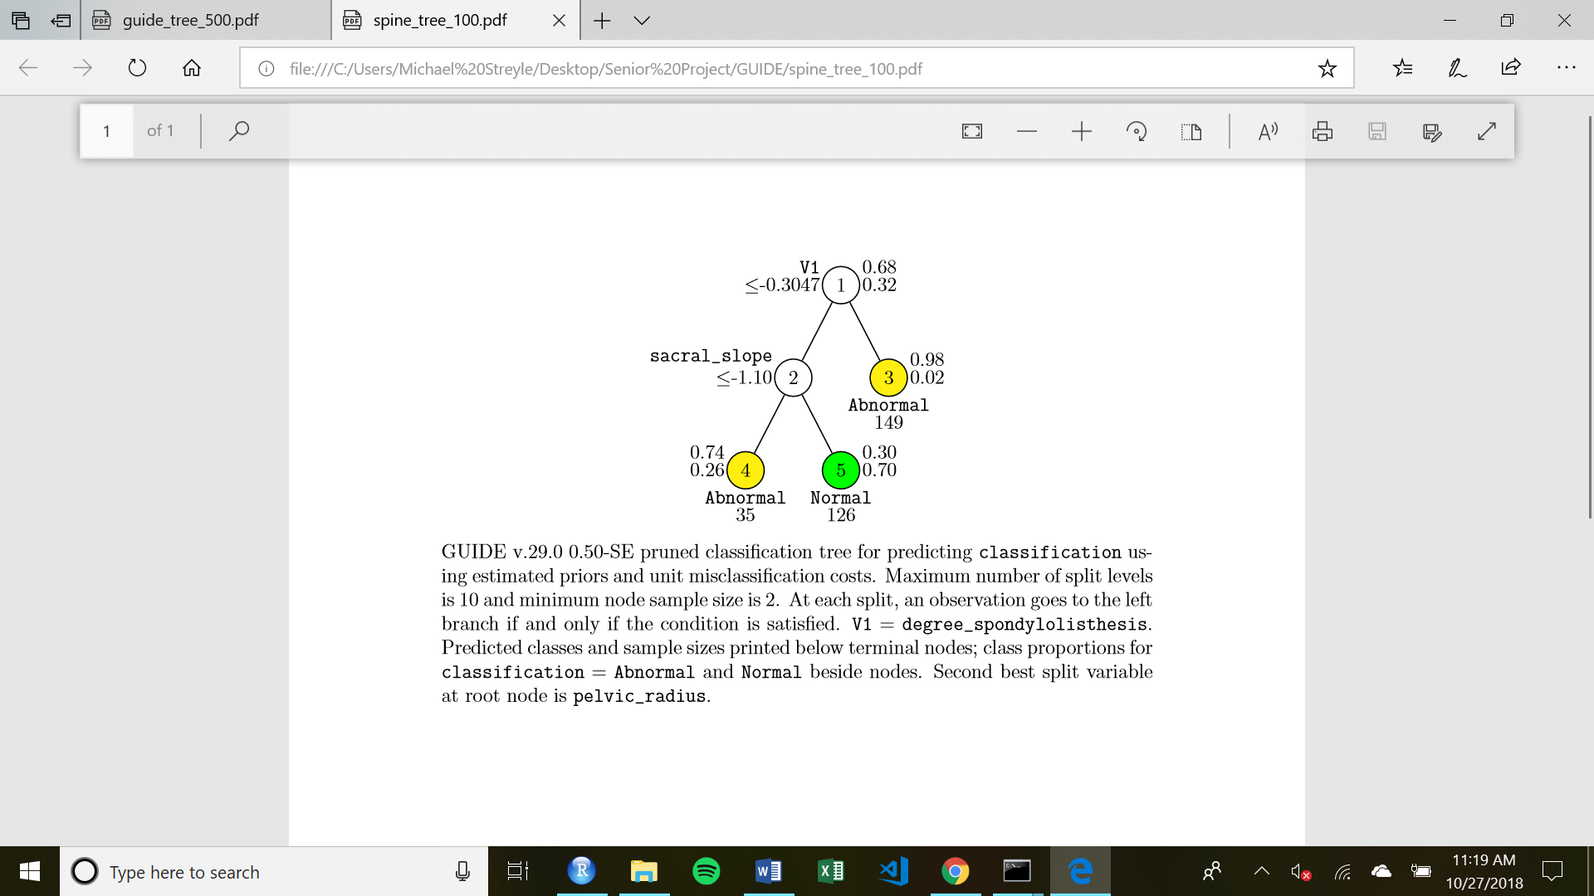

Tree with 500 Random Variables

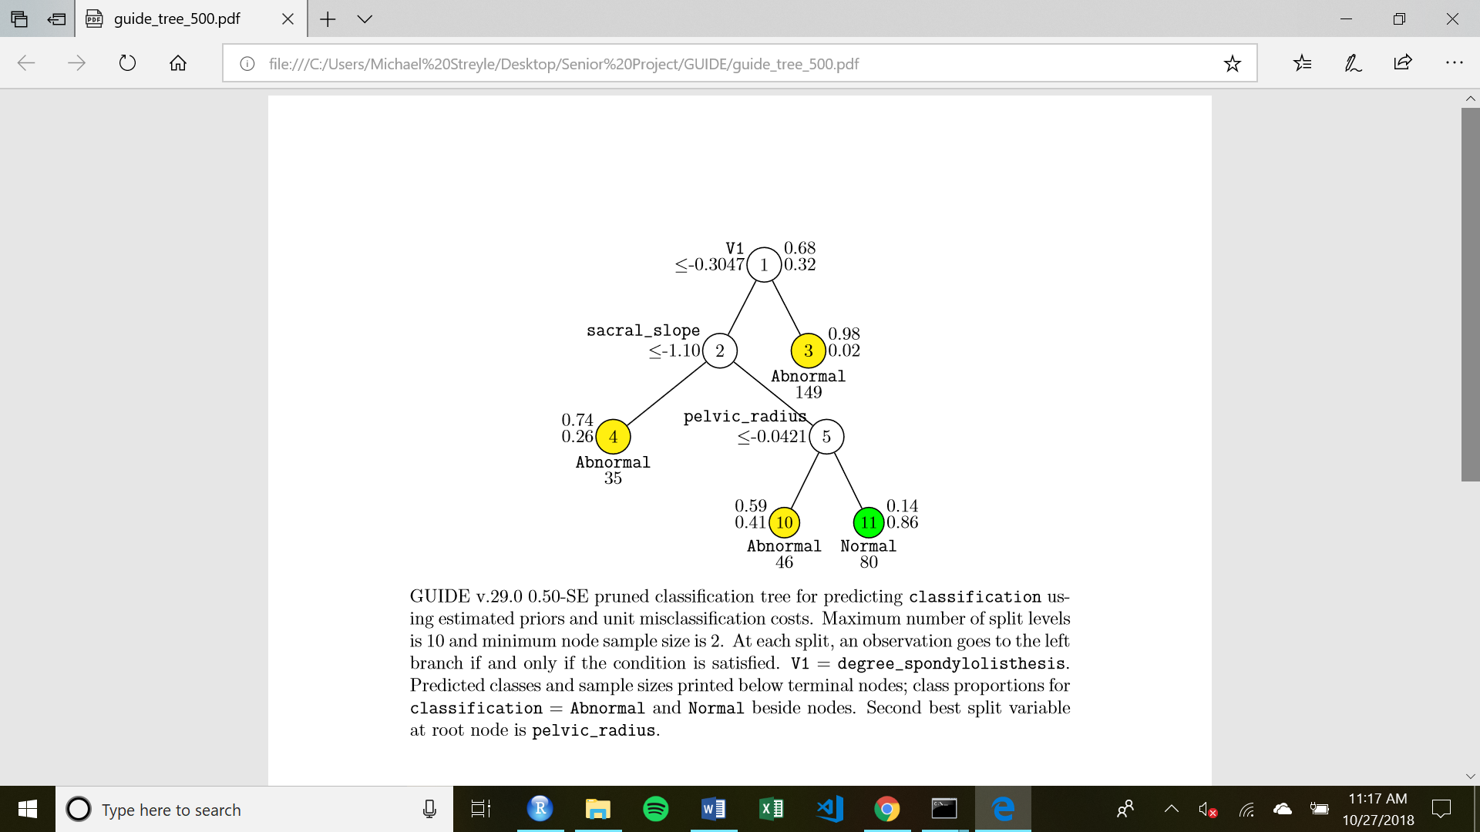

Tree diagram with 1000 Random Variables

